Patient Addressograph


Asthma & Wheeze Education Bundle

This education bundle must be given to families at the time of admission.

It should be used to help with education during the child’s stay in hospital.

It must be completed by parents, nurses and doctors when children and young people present to hospital with an episode of wheeze.

The pack includes:

- Admission checklist - To be completed by families during admission. Once completed it must be signed and filed in patient notes at discharge.

- Personalised Action Plan – Doctors to explain and complete with families and copy given to take home.

- Information on looking after your spacer – Leaflet from the spacer packaging to be given to families at admission

The National Review of Asthma Deaths (NRAD) recommends that follow-up should be arranged after every hospital admission for asthma and for patients who have attended the Emergency Department two or more times with an asthma attack in the previous 12 months.

Checklist for Parents

In hospital

Your child’s wheezing will be treated with repeated doses of inhalers or nebulisers (“Reliever” medicine called Salbutamol). A spacer will be used with the inhaler to ensure the medicine is delivered to the lungs effectively. As your child gets better, the inhalers will be given less often. Once Salbutamol has been reduced to 10 puffs every 4 hours, your child will be ready for discharge home.

All children older than 4 years will be given a course of steroids (Prednisolone). The doctors may decide to give steroids to some younger children, if they are very unwell.

Before discharge from hospital

This Asthma and wheeze education bundle includes a Personalised action plan with information on what to do when your child is unwell with a wheeze, and information on how to look after your spacer.
Please complete this checklist and ensure that the following points are addressed before discharge home:

Your child is on 4 hourly inhalers (Salbutamol) at the time of discharge

You have been given a spacer and shown how to give your child their inhaler with the spacer
You have received information on how to clean and look after your child’s spacer

You have a prescription for a course of oral steroids (if indicated)

If your child is on regular medications for asthma/viral wheeze, these have been reviewed by the doctors and changed if necessary
You have received advice on when to seek medical advice if your child is unwell with a wheeze
You have received a completed Personalised action plan for asthma & pre-school wheeze which has your child’s details on it.
You have discussed with the doctor about whether your child needs a follow-up appointment with the GP or in hospital after discharge

Please return this checklist to your nurse to complete the next section

Checklist for nurses to complete at discharge
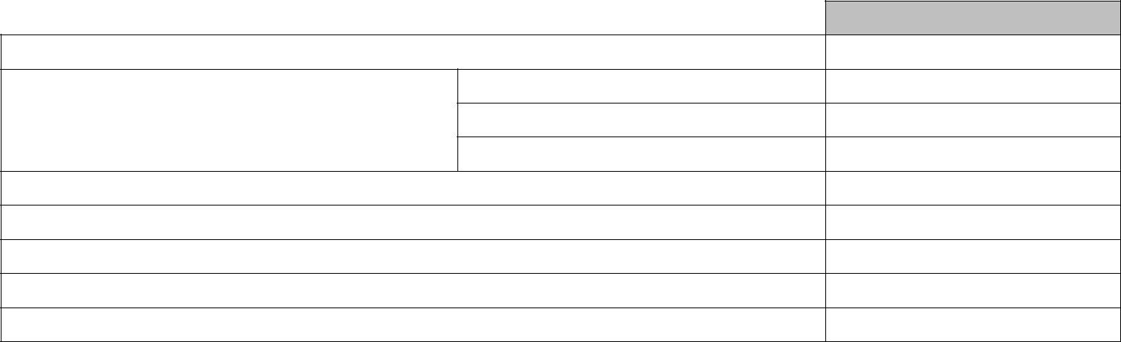
Signed

Have you demonstrated and checked parent’s inhaler technique?

WP10

How have medicines been dispensed? Pharmacy
Ward stock

Has the action plan been completed and given to the family?

Has the NHS Wales Asthmahub been signposted?
Has the parent’s checklist above been completed?

Have any parental questions been answered?

Has the discharge summary been completed?

Please detach this form and file in the notes

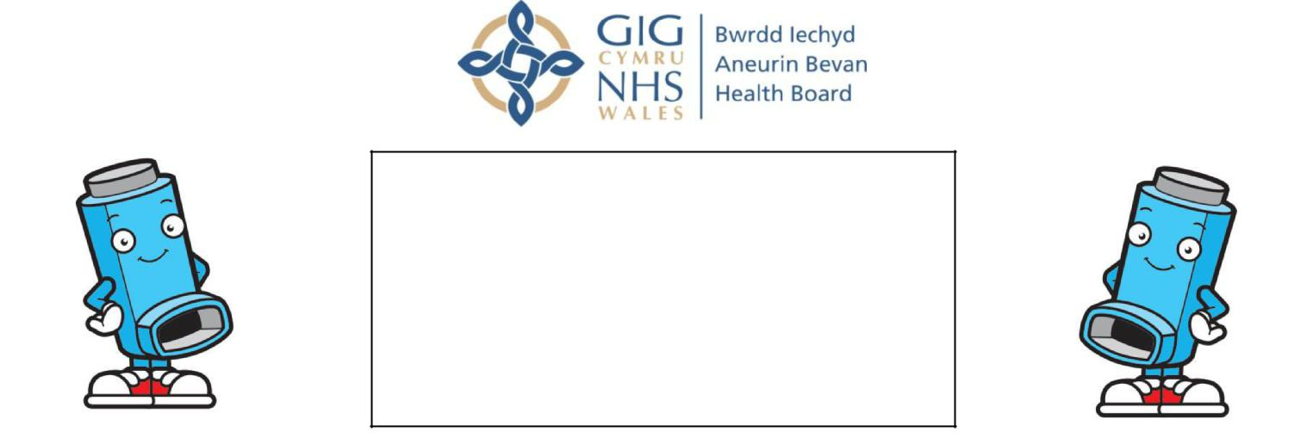
Patient Addressograph

Personalised action plan



Your regular treatment

Preventers (Children under 4yrs may have a diagnosis of viral wheeze and may not be on preventers)

Reliever

Rescue steroids in asthma if appropriate
(Emergency use for subsequent attacks)

Take all inhalers via

• Aerochamber Plus Flow-Vu/mask (yellow) □

- Aerochamber Plus Flow-Vu/mouthpiece (green) □
• Other …………………………………………………….. □

• Dry Powder inhalers □


Managing your wheeze after discharge

- Complete the course of steroid (Prednisolone) if prescribed. Take ………mg once a day for another ……… days
- Your child will need to use the blue reliever inhaler (Salbutamol) via spacer for the next few days.
          - Give 10 puffs every 4 hrs for 24hrs after discharge
    - Then 6 puffs every 4 hrs for next 24 hrs
    - Then 2-10puffs as needed.
- Please check on your child overnight and continue all regular medications
- If your child needs more than 10 puffs 4 hourly of their blue reliever inhaler, please see your GP or visit A&E urgently
- Make an appointment to see your GP in the next 2 working days


Triggers (what makes your child’s symptoms worse)
- If exercise or sport makes it hard to breathe, use ……. puffs of the blue reliever inhaler beforehand
- Viral illness

Please bring this action plan to all appointments, along with all inhalers and spacers

Discharge Date:

Discharging Doctor: Signature:

When your child is well

Use the Preventer treatment regularly as advised

You child may require the blue Reliever inhaler occasionally e.g. with exercise

Always use inhalers with the spacer you have been given

If your child becomes unwell

Your child may have a cold; is coughing or wheezing; waking up at night coughing or wheezing
Use the blue reliever inhaler in a dose of 2-10 puffs every 4-6 hours with a spacer
Continue preventers in usual dose
Make an appointment to see your GP if your child is not better within a few days

If your child is having an asthma attack /wheeze attack

Reliever medication does not last long; your child is short of breath; too breathless to talk or play; having exaggerated movements of tummy muscles
Increase the blue reliever inhaler to 10 puffs every 4 hours through the spacer.

Make an appointment to see your GP on the same day if your child is comfortable on this dose.
Continue preventers in usual dose
Give steroid tablets if you have been advised to use them
If your child is unable to last 4 hours between inhalers seek urgent medical advice (e.g. 999, 111, ED, urgent GP appointment)

Salbutamol 10 puffs can be given via the spacer every 10-15 minutes while you are on your way to the GP/Hospital.

Asthma is serious and can be life threatening. It is vitally important that you recognise when your child is having an asthma attack and take appropriate steps to help treat it.

Useful Resources
www.helpmequit.wales Free advice and support with smoking cessation

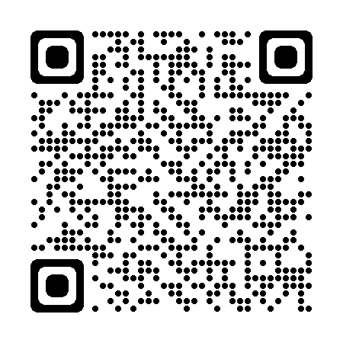
www.ash.org.uk
Health effects of Second-hand smoke.



NHS Wales Athmahub App for Parents:
NHS Wales self-management App for parents of children with Asthma

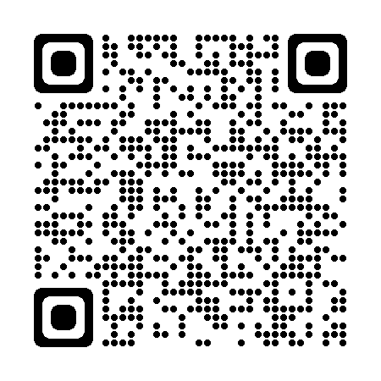

.www.asthmaandlung.org.uk Offers a variety of resources to help you and your child manage their asthma. There are helpful videos on using inhalers correctly
