

**Care Closer to Home (CCTH) for Children**

**Staff Information**

**CCTH working hours**

**The Care Closer to Home Service operates 7 days a week from 8.30am – 6pm.**

**N.B Referrals after 5pm may not be reviewed until the following day.**

**Virtual Handover**

Between the hours of 08.30 and 09.00 the CCTH team will attend the virtual handover via teams with GUH medical staff, therefore no referrals can be accepted for these times. (Please discuss with CCTH team as patient specific)

CCTH nurse will join virtual handover at 08:45 until 09:00 to provide an update on existing patients and may remain on handover from 09:00 – 09:30 to identify new referrals for CCTH from ward.

**On the weekend one member of CCTH team covers North and South team. The CCTH team will notify the Paediatric Patient Flow Co-ordinator on a Friday as to which team is covering that weekend and pass on contact details.**

**Please note last administration of IVAB must be no later than 1630.**

**Referral Process**

**Prior to discharge, please ensure the following; -**

* The medical review indicates that child is medically stable but would benefit from nursing support/ intervention in the community setting. Paediatrician/nurse/family discussion to agree referral and intervention to be delivered by the Care Closer to Home service.
* Nurse refers to CCTH via e -referral process:
  1. Search for patient on CWS.
  2. Under Documents select “create CWS eform”

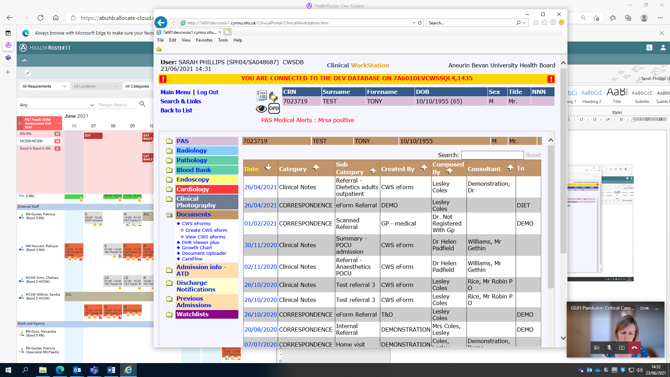

* 1. Type CCTH in the search box then “Select” Referral- Care Closer to Home - children

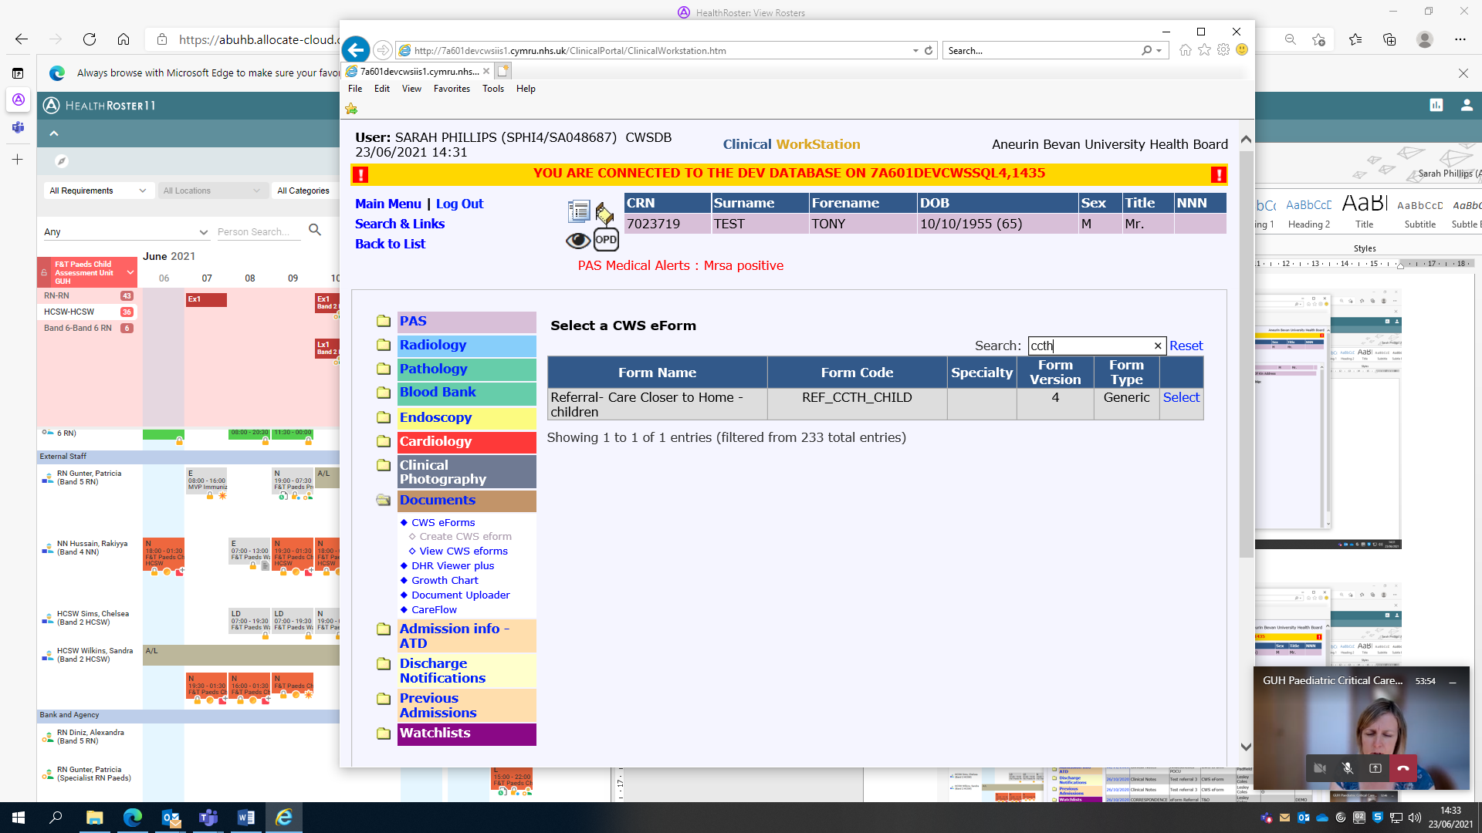

* 1. Fill in each of the section on the eform. Identifies mandatory field

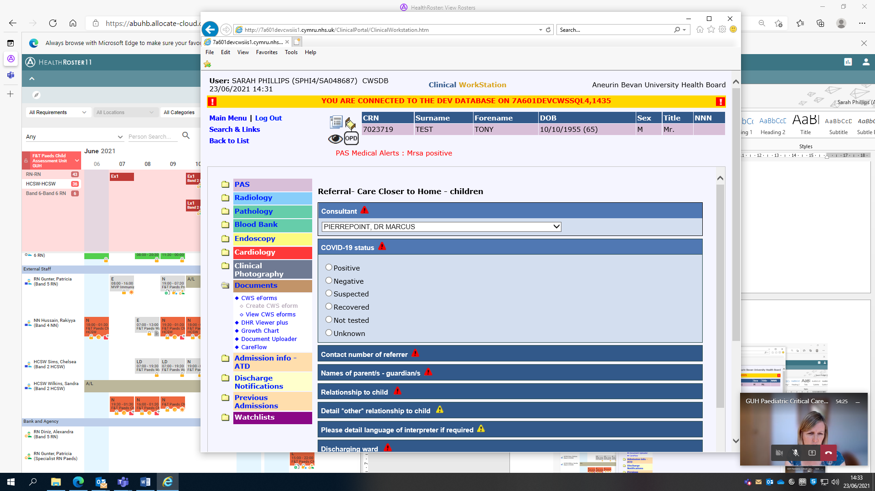

* 1. Select “Preview”

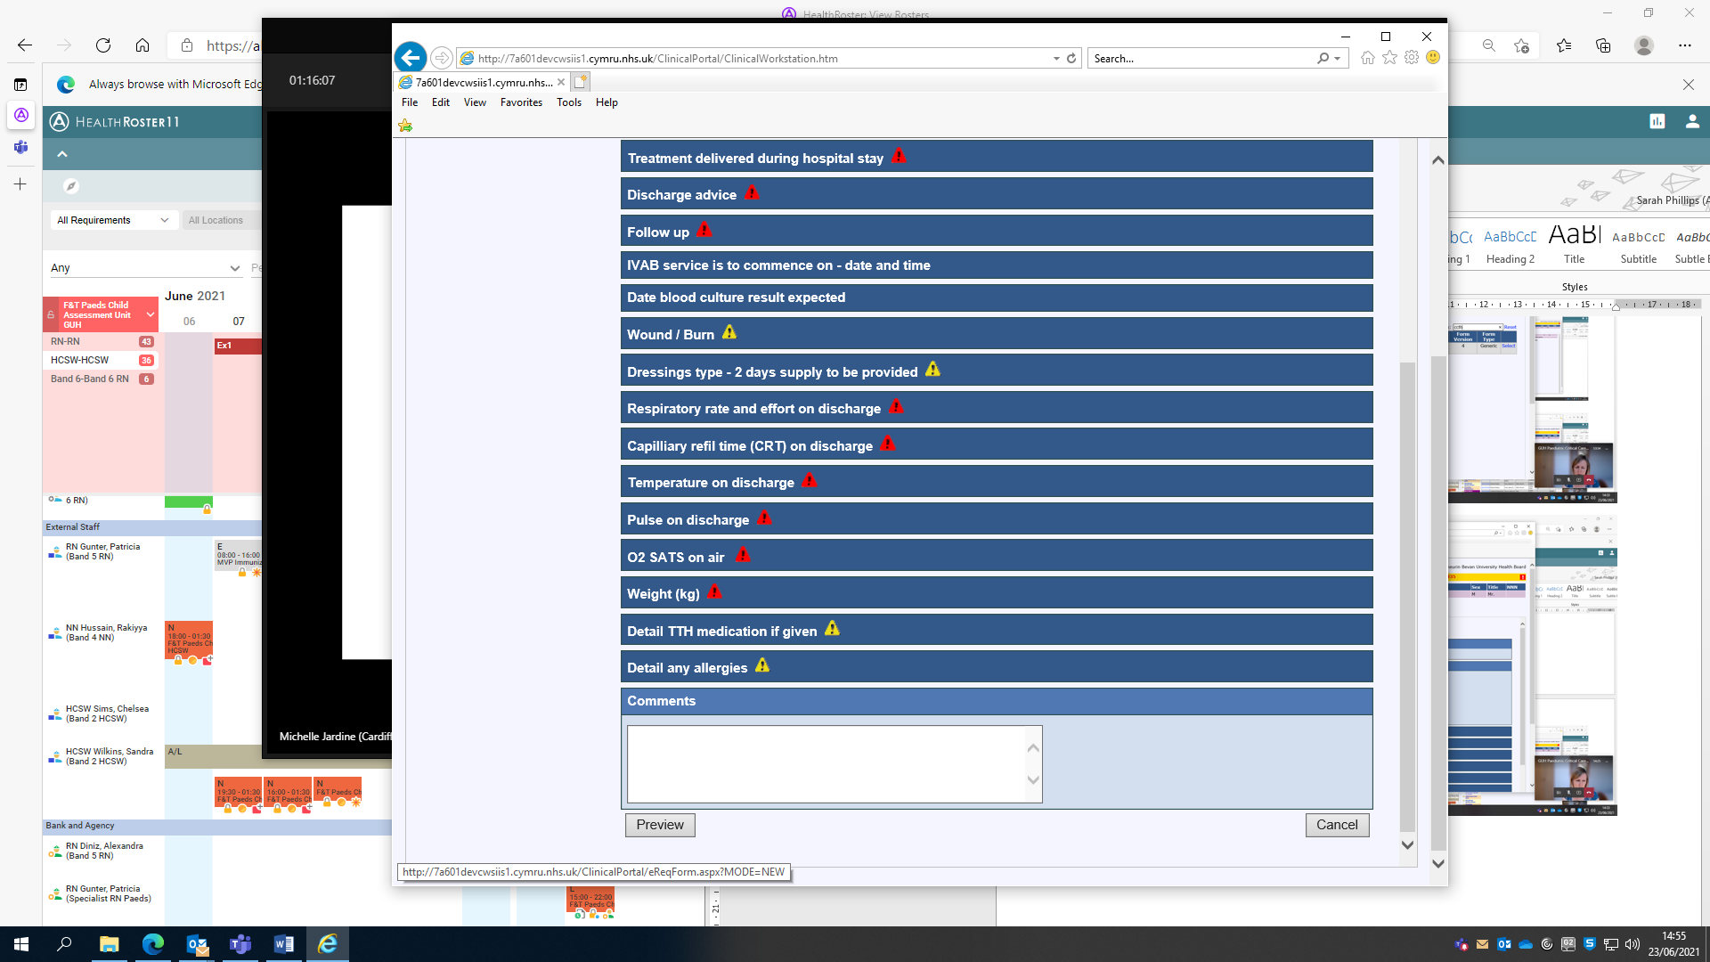

* 1. Check the details and select “Save”

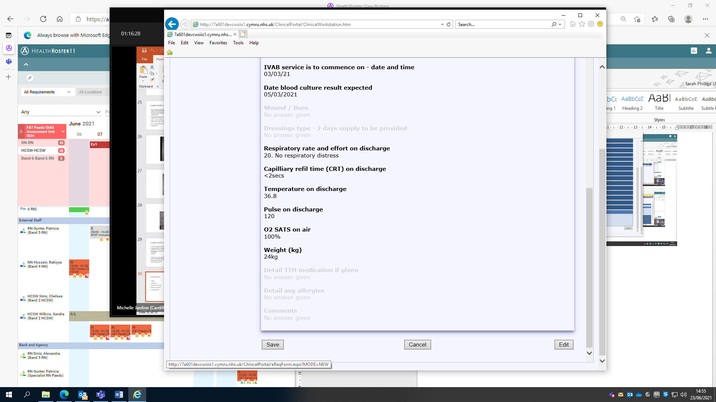

* 1. The form will now be viewable in the documents list

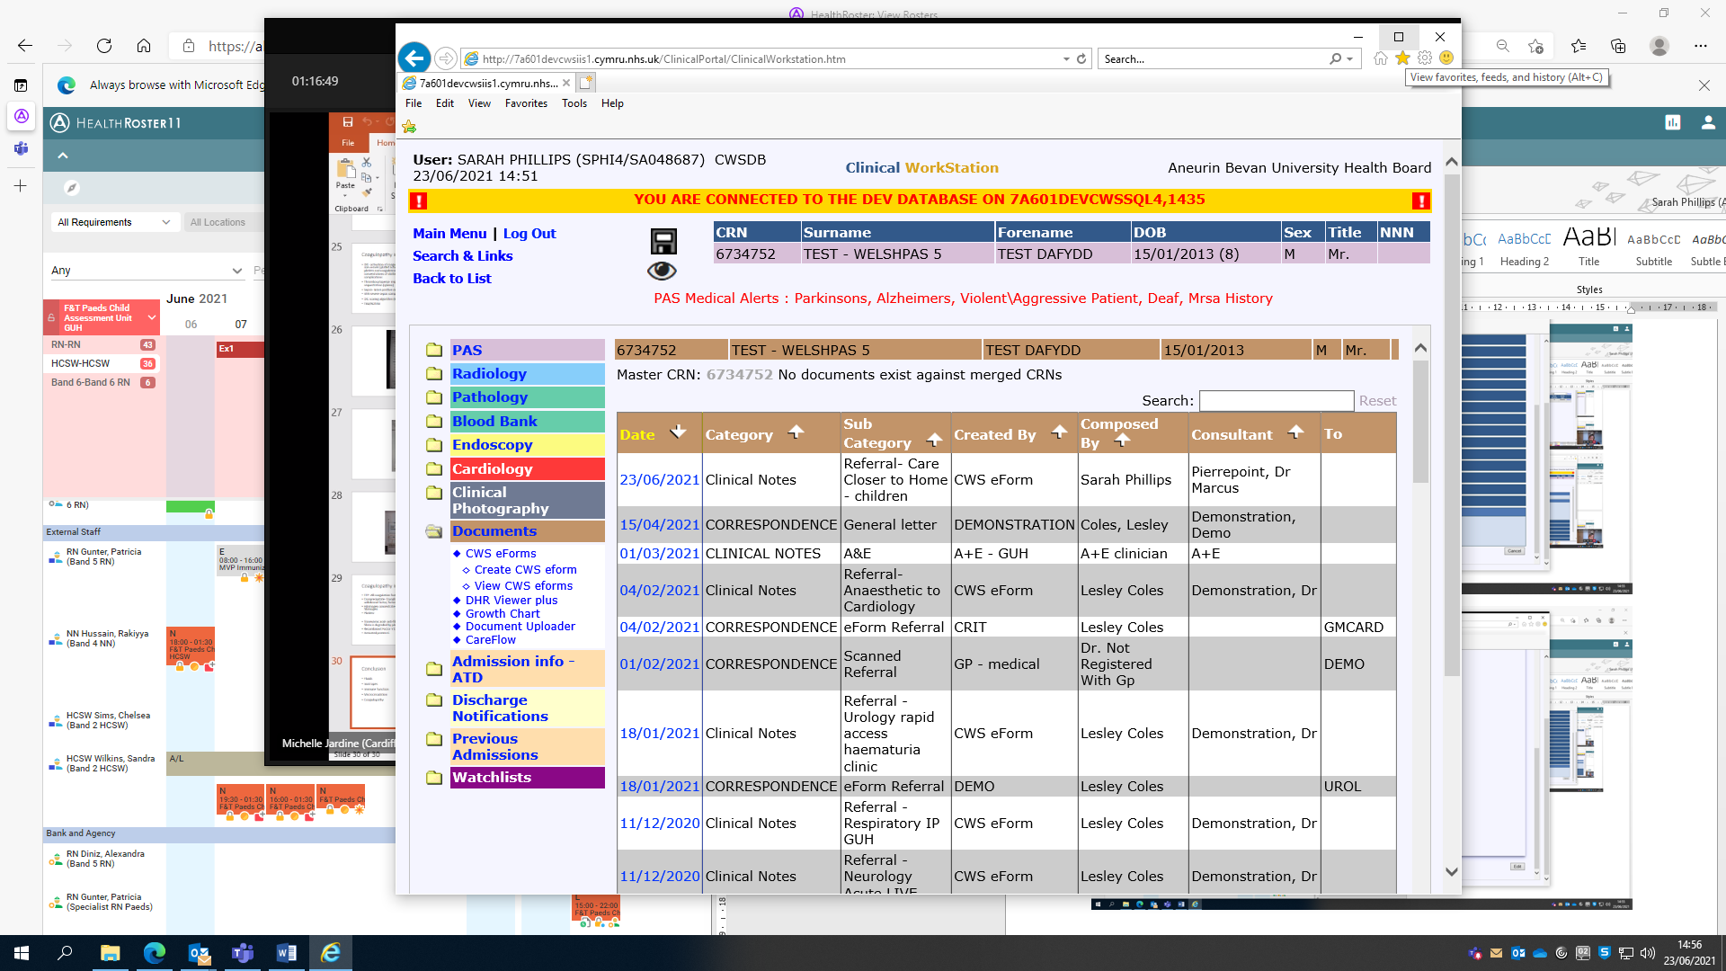

* Along with e-referral, the hospital nurse **must** phone CCTH team on **01633 618010 (CCTH Main office in Risca Health centre)** to confirm whether referral will be accepted. If no one-picks up the CCTH referral then a nurse will aim to respond asap.

**Discharge planning**

* On referral acceptance the hospital nurse prepares the discharge pack (documentation and equipment) which goes with the child and family:
  1. Fluid chart
  2. Completed Drug chart (ensure Lidocaine prescribed if IMAB required)
  3. Cannula Care Bundle (if child is for IV management)
  4. Current PEWS observation chart (this is important as it will indicate clinical change)
  5. Fluid challenge chart and Dioralyte (where appropriate)
  6. Dressings (2 days supply)
  7. Medications (the CCTH team have a supply of IV Ceftriaxone)
  8. Please ensure the families contact details are included in the referral for CCTH to contact the family.
* If a patient is referred out of hours – hospital nurse leaves time of referral and CRN on the answerphone message. The CCTH nurse will check answerphone and CWS each morning for new referrals.
* Parents/carer will be provided with the CCTH Parent Information Leaflet as well as a written advice leaflet or website information with further information about the child’s condition and what to expect over the next few days. Please inform parents that **they are generally expected to travel to attend the CCTH clinics (North – YYF Childrens OPD or South – Serennu Children’s Centre) for appointments, however on occasions this may be a home visit. This will be discussed with family and ward.**

**Discharge from CCTH**

* The patient’s medical notes must remain in the clinical area until intervention complete. When CCTH intervention is complete the documentation is returned and amalgamated prior to scanning/sending to health records.
* **Patients will have open access to the ward for clinical review by a Paediatrician if there is cause for clinical concern or signs of deterioration.**