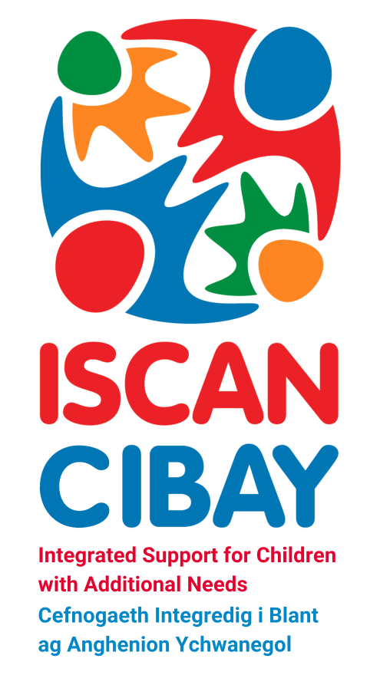
ISCAN Care Co-ordination
ISCAN Care Co-ordination aims to support and empower families whose child has an identified developing condition or disability which has the potential to significantly impact upon their long-term development and / or function. To help families come to terms with their child’s/young person’s needs and difficulties, to help families build confidence and realise their strengths, goals and aspirations.

What is Care Co-ordination?
Care co-ordination supports parents/carers of a child/young person from birth to age 18 who has been identified as requiring additional support to enable them to meet their full potential. We aim to identify the combined needs of the family and help them navigate and understand the services available to them and their child/young person. We are effective in being the first point of contact for parents/carers and bring together multidisciplinary teams who support children/young people’s complex health and care needs.

How can we help you?
A Care Co-ordinator/Family Support Worker can provide support and advice, this may include;
- Co-ordination of care with involved professionals and services
- Accessing and managing appointments
- Support with education including; nursery and school planning and 1:1 support, if deemed appropriate
- Team Around the Family (TAF) meetings
- Information on local groups and other agencies
- Referrals and signposting onto other agencies / services (where required)

For more information, please contact the ISCAN Care Co-ordination team -
Caerphilly Children’s Centre – 02920 867 447
Nevill Hall Children’s Centre – 01873 732 712
Serennu Children’s Centre – 01633 748 000
E-mail: ABB.CareCo-ordination@wales.nhs.uk

